**Accommodation values for property types in Surulere, Yaba, Ilupeju and Gbagada axis between 2019-2023**

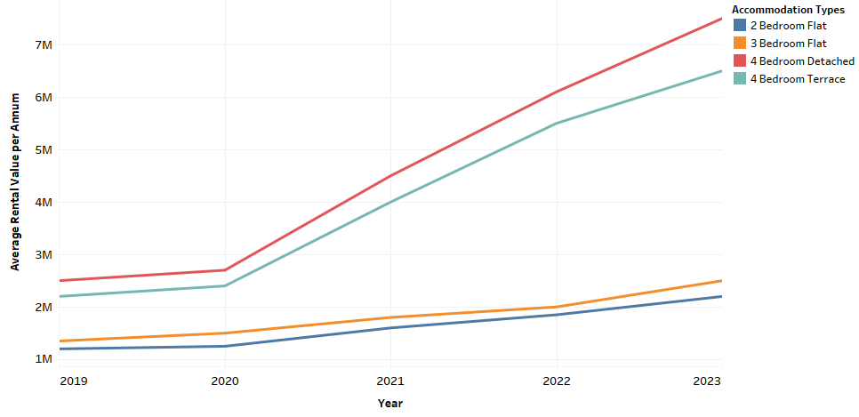

**Accommodation values for property types in Amuwo-Odofin, Isolo and Festac axis between 2019-2023**

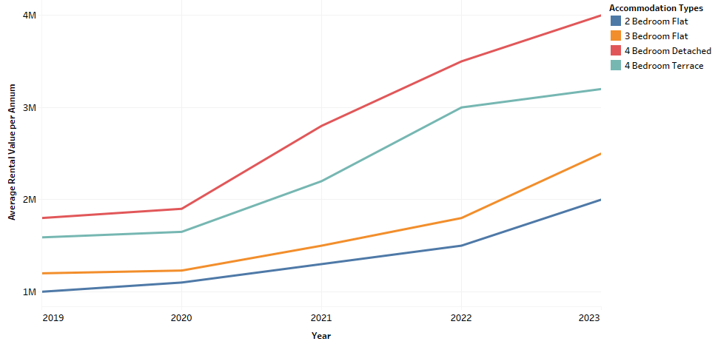

Accommodation values for property types in Ikeja GRA, Ikeja Main and Maryland axis between 2019-2023

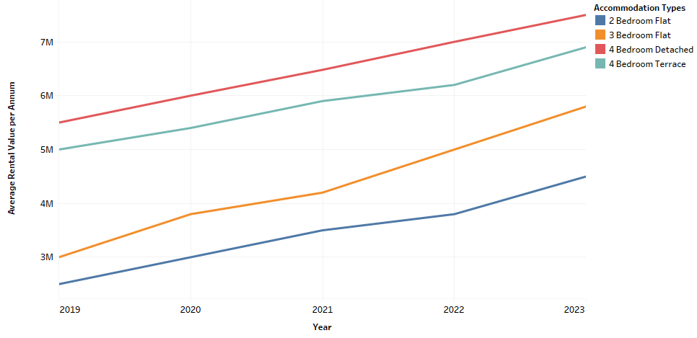

Accommodation values for property types in Ogudu and Magodo axis between 2019-2023

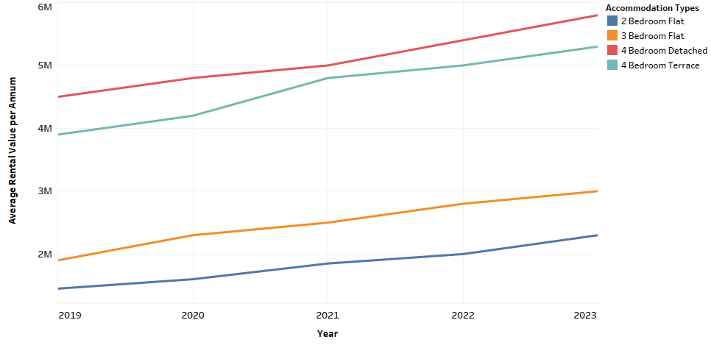

Accommodation values for property types in Apapa axis between 2019-2023

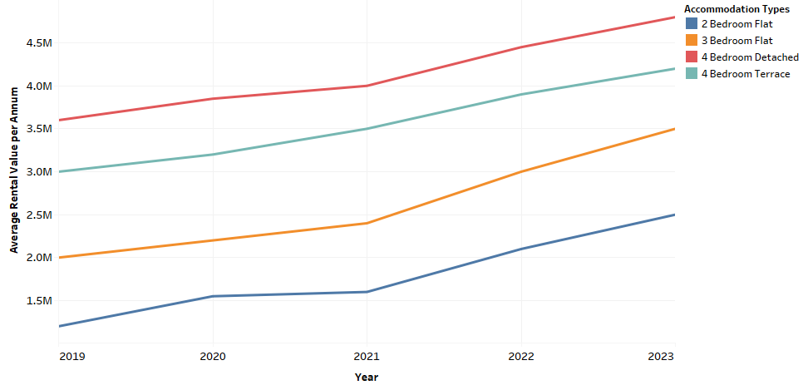

Accommodation values for property types in Ikorodu axis between 2019-2023

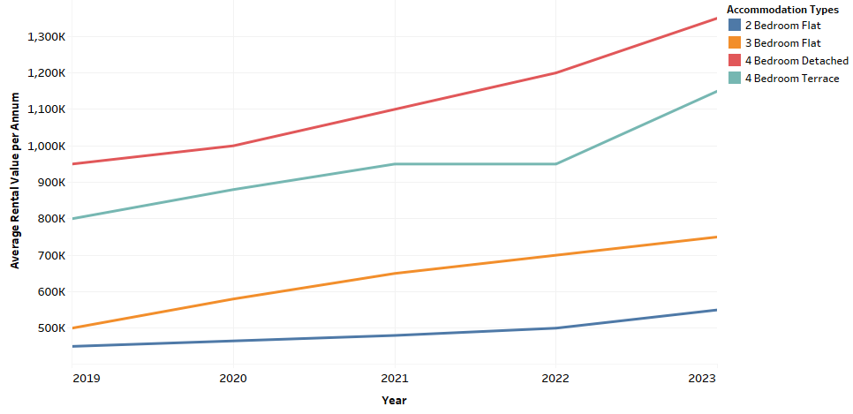

**Accommodation rental values for offices in Lagos Mainland axis between 2019-2023**

